**Math 120  
3.2 Polynomial Functions and Their Graphs**

**Objectives:**

1. Identify polynomial functions.
2. Recognize characteristics of graphs of polynomial functions.
3. Determine end behavior.
4. Use factoring to find zeros of polynomial functions.
5. Identify zeros and their multiplicities.
6. Understand the relationship between degree and number of turning points.
7. Graph polynomial functions.

# Topic #1: Polynomial Functions

The definition of a polynomial function with degree is:

where **is a non-negative integer and .**



* is the *_______________*

(this is the term of ***highest degree***)

* The polynomial has



* The graph of the polynomial function has at most ______________________turning points



Polynomial functions have smooth and continuous graphs. ***The domain of any polynomial is __________________***



since there is no possibility to divide by zero OR no possibility to take a negative even root.



*Example #1* – Determine if the Function is a Polynomial; State the Degree and Leading Coefficient

a)

This is a polynomial. All the powers are non-negative integers (whole numbers). The degree is ___________and the leading coefficient is ________



Putting the degree and leading coefficient together gives the dominant term _______________



Is a polynomial? ___________



Degree_____________

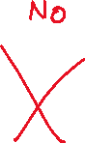

Leading coefficient____________

Dominant Term ______________



Is a polynomial? ___________

Degree_____________

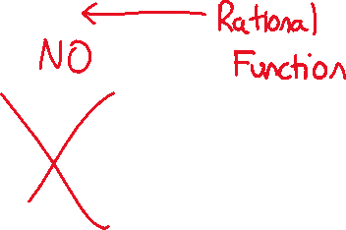

Leading coefficient____________

Dominant Term ______________

Is a polynomial? ___________



Degree_____________



Leading coefficient____________



Dominant Term ______________

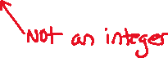

Is a polynomial? ___________



Degree_____________

Leading coefficient____________

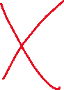

Dominant Term ______________

# Topic #2: End Behavior of Polynomial Functions and the Leading Coefficient Test

End behavior describes what the graph of a function looks like when gets very large (toward positive infinity) and very small (toward negative infinity).

***For polynomials, end behavior is determined by the ___________________________________________***



***– in other words, this is the DOMINANT TERM.***



When looking at the degree and leading coefficient, there are only four possibilities:



The degree () can either be **_________________**



The leading coefficient () can be **___________________**



Here are the four possible end behaviors:

This shows the 4 possible end behaviors for a polynomial:
odd/negative
odd/positive
even/positive
even/negative
Please ask an interpreter for further detail 



Although there are infinitely many polynomials, there are only four possible end behaviors. The variation between polynomials is in the middle!

*Example #1* – Use the End Behavior to Classify the Polynomial

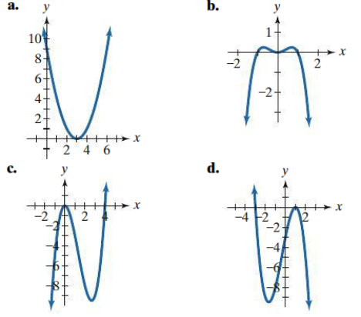

These are all polynomials. Notice they are all smooth and continuous graphs.

a)



b)



c)



d)



*Example #1* – Use the Leading Coefficient Test to Describe the End Behavior

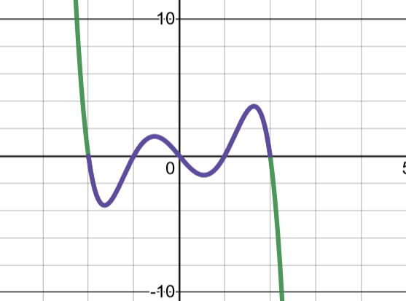a)

The dominant term is ______________



so is _______________



Therefore, the end behavior is?



The dominant term is ______________



so is _______________



Therefore, the end behavior is?



Graph to confirm.



c)



The dominant term is ______________



so is _______________



Therefore, the end behavior is?



Graph to confirm.



d)



The dominant term is ______________



so is _______________



Therefore, the end behavior is?



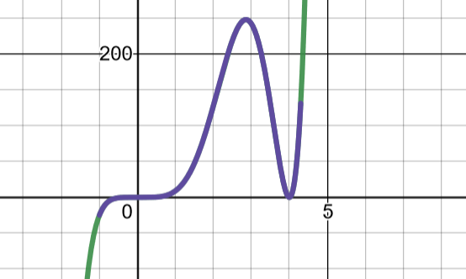



# Topic #3: Zeros of Polynomial Functions and Multiplicity

**Factors to Zeros**

A zero of a function is where the graph meets the __________



The zeros of a polynomial can be determined by factoring and setting each factor _______________________



This is the Zero/Factor Rule. Here we will look at polynomials already in factored form.

Consider the polynomial:



Technically, there are 3 factors:



However, ***the factor is repeated twice***.



So, we say this factor has ***____________________***



For efficiency, we set each UNIQUE factor to zero and solve:



A graph confirms:

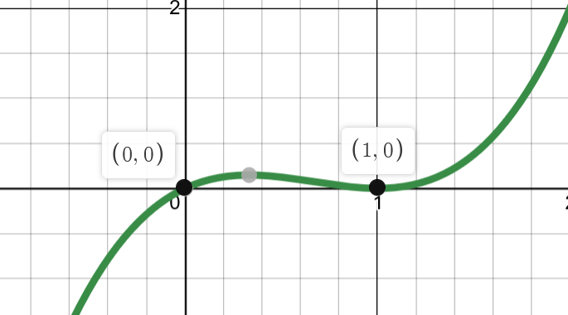

The Zero/Factor Rule formally states: **If is a factor, then is a zero.**

*Example #1* – Find the Zeros and state their multiplicity (if multiplicity is greater than 1):

a)

Set the factors equal to zero and solve:



b)



Set the factors equal to zero and solve:

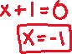

c)

Set the factors equal to zero and solve:



NOTE: It is customary to write the zeros in order from least to greatest. For example, the zeros in the last example should be written in order as **_______________**



***Multiplicity of Zeros and their significance***

The multiplicity describes the shape of the graph as it meets the -axis.

If a factor is to an ***______________***power, the corresponding zero meets the -axis and **crosses** it.



If a factor is to an ***______________***power, the corresponding zero meets the -axis and **turns around**.



The polynomial has 2 **unique** factors. The first factor is an ______________ power, making the zero an ODD multiplicity so the graph will ___________ at x=0.



The second factor is an ____________power and repeats twice, making the zero an EVEN multiplicity so the graph will _____________ at x=1.



The graph confirms the shapes of both zeros:

The degree of this polynomial is and so there must be zeros. This is true; it just happens that one of the zeros has a multiplicity of 2. Technically, we could write the zeros as



*Example #2* – Use Multiplicity to Describe the Shape of the graph at each Zero

a)

In order, the UNIQUE zeros are ___________



Since the factor is a SECOND power _______ the zero has a multiplicity 2 so the _______________________



Since the factor is a FIRST power __________ the zero has multiplicity of and _________________



Graph to confirm.

b)

In order, the UNIQUE zeros are



Since the factor is a FIRST power, the zero has multiplicity of and



Since the factor is a SECOND power, the zero has multiplicity of and



Since the factor is a FIRST power, the zero has multiplicity of and



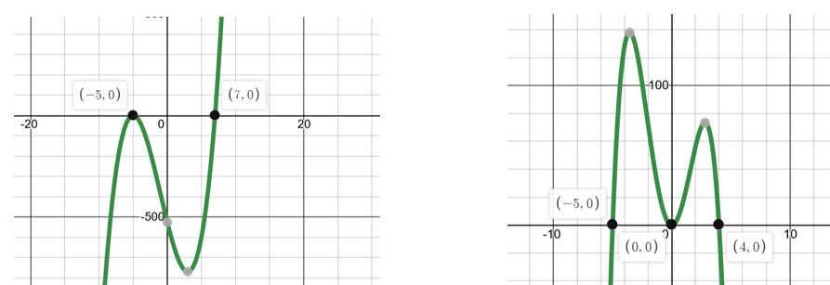

A graph of both confirms the ZEROS and their SHAPES. We could also multiply out the polynomials to look at the dominant term to show the end behavior matches what we see in the graphs.

# Topic #4: Sketching a Polynomial

We can use End Behavior, Zeros, Multiplicity, and the -intercept, to sketch a graph of a polynomial.

Consider the polynomial:

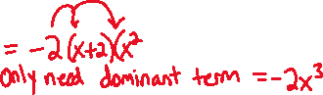

a. Determine End Behavior

The Dominant Term is:



this indicates the polynomial has a of degree _________



Since is _________ and _____________



the End Behavior is ______________________________



b. Find the zeros.

Since the polynomial has a degree of there MUST be 3 zeros. Set the factors to zero and solve:



The second factor repeats so has a multiplicity of 2; technically the zeros are

The zero at has a multiplicity of ___________



so the graph __________________ at *x* = 1.



The zero at has a multiplicity of _________



so the graph _____________________ at *x* = -2.



c. The -intercept is when .

Therefore,



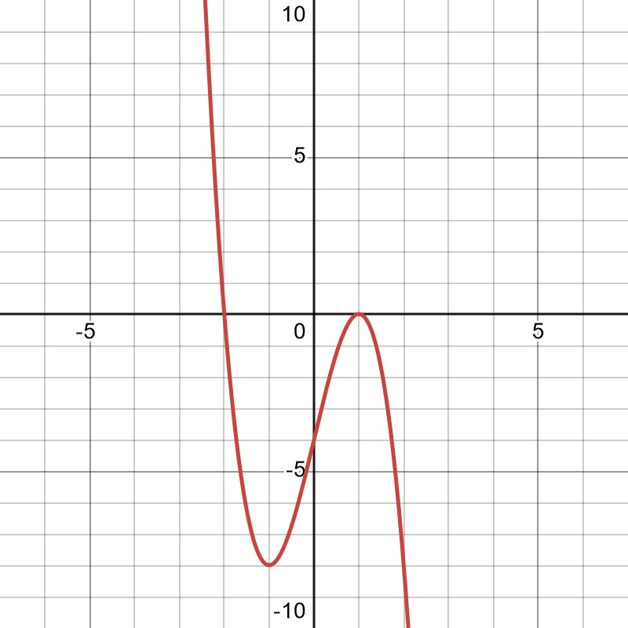

Ultimately, it is best to look at the graph of the function first to confirm End Behavior, Zeros/Multiplicities, the -intercept, and any symmetry.

However, it is good to understand WHY the graph looks the way that it does.

Note: Some polynomials have zeros that are COMPLEX and ____________________the -axis. Nonetheless, a polynomial of degree must have zeros – real, complex, or a combination of both!



**Topic #5: Converting Factors into Zeros**

The Zero/Factor Rule is a two-way street:

If is a factor, then is a zero.

If is a zero, then is a factor.

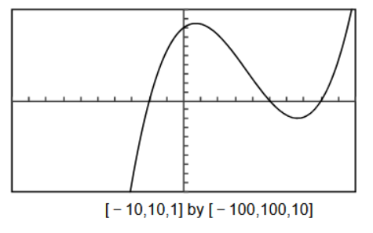Consider the graph of the polynomial and ***note the scale*** along **both** axes.

Use the graph to find the equation of the polynomial – leave the equation in ***factored form***:



a) Find the zeros and state whether the multiplicity of each zero is even or odd.

The UNIQUE zeros are at



The zero at crosses and so has an _______________multiplicity. The smallest possible multiplicity is:



The zero at crosses and has an _________________multiplicity. The smallest possible multiplicity is:



The zero at crosses and has an _________________multiplicity. The smallest possible multiplicity is:



Using the smallest multiplicities possible, how many zeros are there?



b) Write an equation, expressed as the product of factors, of a polynomial function that might have the graph. Use a leading coefficient of 1 or -1 and make the degree of f as small as possible.

Assuming the smallest multiplicities possible, what is the degree of the polynomial? n =



Using the zero/factor rule in reverse, we can turn the zeros into factors:



The factors make the equation of the polynomial:



To find the leading coefficient , we look at the end behavior of the graph. If a = 1 (positive) then the end behavior should go up. If a = -1 then the end behavior should go down.



Using the zeros and the found “a” value gives us the equation for the polynomial of degree graphed above:



*Example #1* – Use the Graph to Find the Equation of the Polynomial; Leave in Factored Form

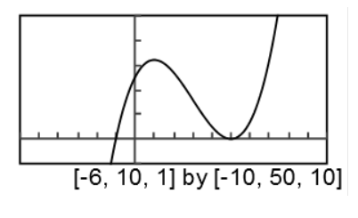



a) Find the zeros and state whether the multiplicity of each zero is even or odd.

The UNIQUE zeros are at



The zero at crosses and so has an _______________multiplicity. The smallest possible multiplicity is:



The zero at turns around and has an _________________multiplicity. The smallest possible multiplicity is:



Using the smallest multiplicities possible, how many zeros are there?



b) Write an equation, expressed as the product of factors, of a polynomial function that might have the graph. Use a leading coefficient of 1 or -1 and make the degree of f as small as possible.

Assuming the smallest multiplicities possible, what is the degree of the polynomial? n =



Using the zero/factor rule in reverse, we can turn the zeros into factors:



The factors make the equation of the polynomial:



To find the leading coefficient , we look at the end behavior of the graph. If a = 1 (positive) then the end behavior should go up. If a = -1 then the end behavior should go down.



Using the zeros and the found “a” value gives us the equation for the polynomial of degree graphed above:



*Example #2* – Use the Graph to Find the Equation of the Polynomial; Leave in Factored Form

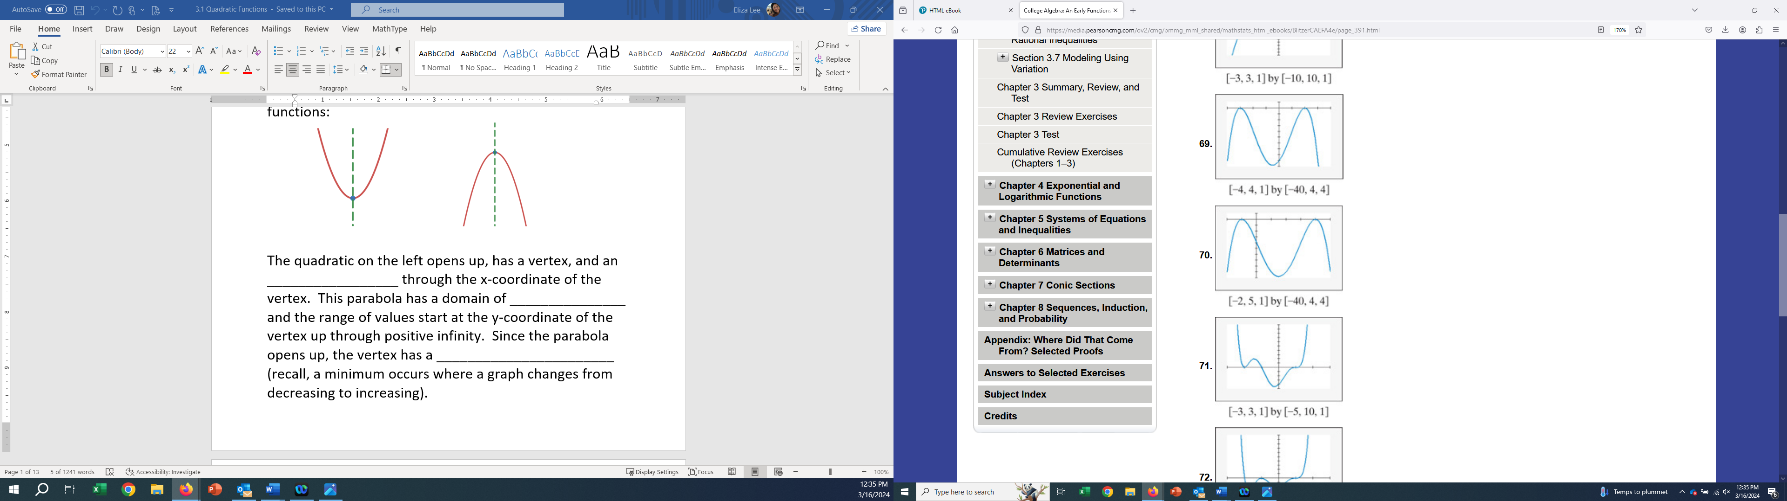

[-4,4,1] by [-40,4,4]

a) Find the zeros and state whether the multiplicity of each zero is even or odd.

The UNIQUE zeros are at



The zero at turns around and so has an _______________multiplicity. The smallest possible multiplicity is:



The zero at ______turns around and has an _________________multiplicity. The smallest possible multiplicity is:



Using the smallest multiplicities possible, how many zeros are there?



b) Write an equation, expressed as the product of factors, of a polynomial function that might have the graph. Use a leading coefficient of 1 or -1 and make the degree of f as small as possible.

Assuming the smallest multiplicities possible, what is the degree of the polynomial? n =



Using the zero/factor rule in reverse, we can turn the zeros into factors:



The factors make the equation of the polynomial:



To find the leading coefficient , we look at the end behavior of the graph. If a = 1 (positive) then the end behavior should go up. If a = -1 then the end behavior should go down.



Using the zeros and the found “a” value gives us the equation for the polynomial of degree graphed above:

